Test A
Name ________________________ Class ________________ Date _________________

GRAMMAR
1 | Complete the sentences with the correct form of there is / there are.
/7
 | 1. | _________________ 17 boys in my class.
 | 2. | _________________ a poster above your bed? Yes, _________________
 | 3. | _________________ a computer on the desk.
 | 4. | _________________ any books in her bag.
 | 5. | _________________ any girls in your maths class? No, _________________

2 | Circle the correct words.
/5
 | 1. | There's / There are three posters in my bedroom.
 | 2. | There's / There are a new girl in my class.
 | 3. | There's / There are a cat under the table.
 | 4. | There's / There are ten apples on the floor.
 | 5. | There's / There are a computer on the desk.

VOCABULARY
3 | Write the name of the furniture in the room.
/7
 | 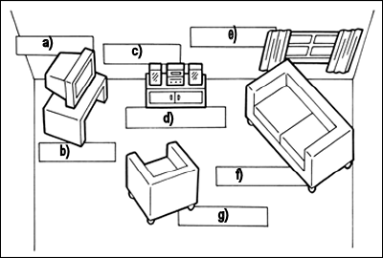

4 | Write the name of the furniture in the bedroom.
/6
 | 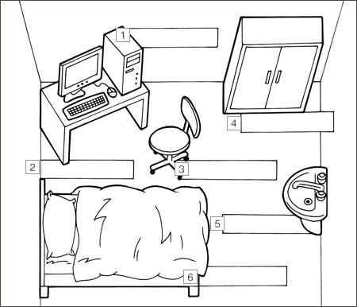

5 | Write the names of the furniture.
/7
 | 1. | dearbowr ________________________
 | 2. | koecro ________________________
 | 3. | mahiarcr ________________________
 | 4. | geirdf ________________________
 | 5. | foas ________________________
 | 6. | burpacod ________________________
 | 7. | rautsinc ________________________

